CSE471 - System Analysis Report
Crypto World Bank: System Analysis Diagrams
Course: CSE471 - System Analysis
Project: Decentralized Crypto Reserve & Lending Bank
Date: 2024
Authors: Md. Bokhtiar Rahman Juboraz (20301138) • Md. Mahir Ahnaf Ahmed (20301083)

Contents
1 | Project Overview
2 | System Request and Business Value
3 | Diagram Index
4 | Use Case Diagram
5 | Activity Diagrams
6 | Data Flow Diagrams
7 | Sequence Diagrams
8 | Structure Charts and Program Specifications
9 | Logical to Physical Data Models
10 | User Interface Design
11 | Project Timeline and Resource Allocation
12 | Diagram Summary

1. Project Overview
The Crypto World Bank is a decentralized lending platform with hierarchical banking (World Bank → National Banks → Local Banks → Users). This report presents the system analysis diagrams for the platform (Prethesis 1 scope).

2. System Request and Business Value
2.1 System Request
• Project sponsor: BracU CSE (BCOLBD 2025 guideline).
• Business need: Transparent, on-chain lending with AI/ML fraud detection; hierarchical banking structure for scalability.
• Expected benefits: Auditability, reduced fraud risk, financial inclusion via crypto-backed loans.
2.2 Feasibility Study
Type | Outcome
**Technical** | Feasible — EVM/Solidity, React, PostgreSQL, ML (Random Forest, Isolation Forest) are mature.
**Economic** | Feasible — free testnets, Vercel/Render free tier, no real crypto required.
**Operational** | Feasible — 2-person team, 8-week timeline, supervisor oversight.

Full feasibility analysis: WHITEPAPER_BCOLBD2025.md §VII.

3. Diagram Index (All Files in Documentation/Diagrams/CSE471/)
File Name | Section
Usecase diagram.png | §4 Use Case Diagram
Activity Diagram - Loan Request to Repayment Flow.png | §5.1
Activity Diagram Hierarchical Banking Flow.png | §5.2
Activity Diagram Income Verification Flow.png | §5.3
Activity Diagram Chat System Flow.png | §5.4
Activity Diagram AI Chatbot Interaction Flow.png | §5.5
activity diagram Market Data Viewing Flow.png | §5.6
Activity Diagram Profile Management Flow.png | §5.7
Dataflow Diagram (Context Diagram Level - 0).png | §6.1 Data Flow Context
Data flow diagram (level - 1) .png | §6.2 Data Flow Level 1
dataflow diagram 2 (level -1).png | §6.2 Data Flow Level 1
Sequence Diagram 1 Loan Request, AI Risk Check, and Approval Decision.png | §7.1
Sequence Diagram 1B Reject Path — alt [Reject].png | §7.2
Sequence Diagram 2 Installment Payment Loop.png | §7.3
Sequence Diagram 3 Income Verification.png | §7.4
Sequence Diagram 4 Chat System.png | §7.5
Sequence Diagram 5 AI Chatbot Interaction.png | §7.6
Sequence Diagram 6 Hierarchical Banking (World Bank → National Bank → Local Bank → Borrower).png | §7.7
Sequence Diagram 7 Market Data Retrieval.png | §7.8
Sequence Diagram 8 Borrowing Limit Calculation.png | §7.9

4. Use Case Diagram
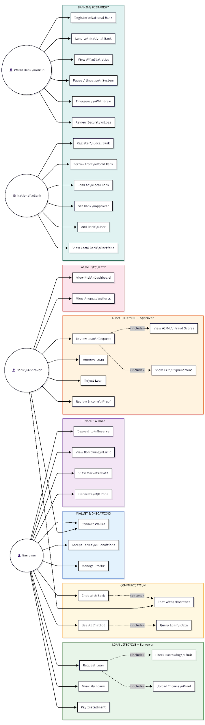
Description: Shows actors (Borrower, Bank User, World Bank, National Bank, Local Bank) and their interactions with the system.

5. Activity Diagrams
5.1 Loan Request to Repayment Flow
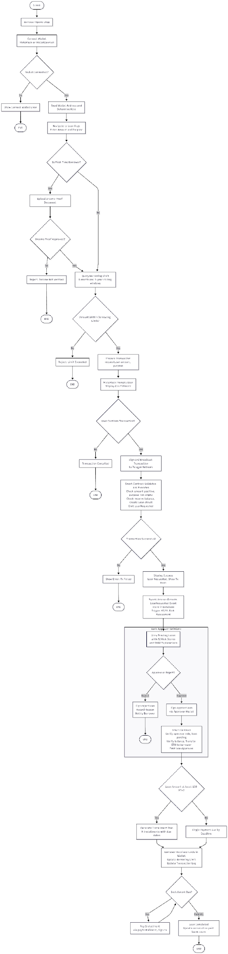
Description: End-to-end flow from loan request through approval to repayment.
5.2 Hierarchical Banking Flow
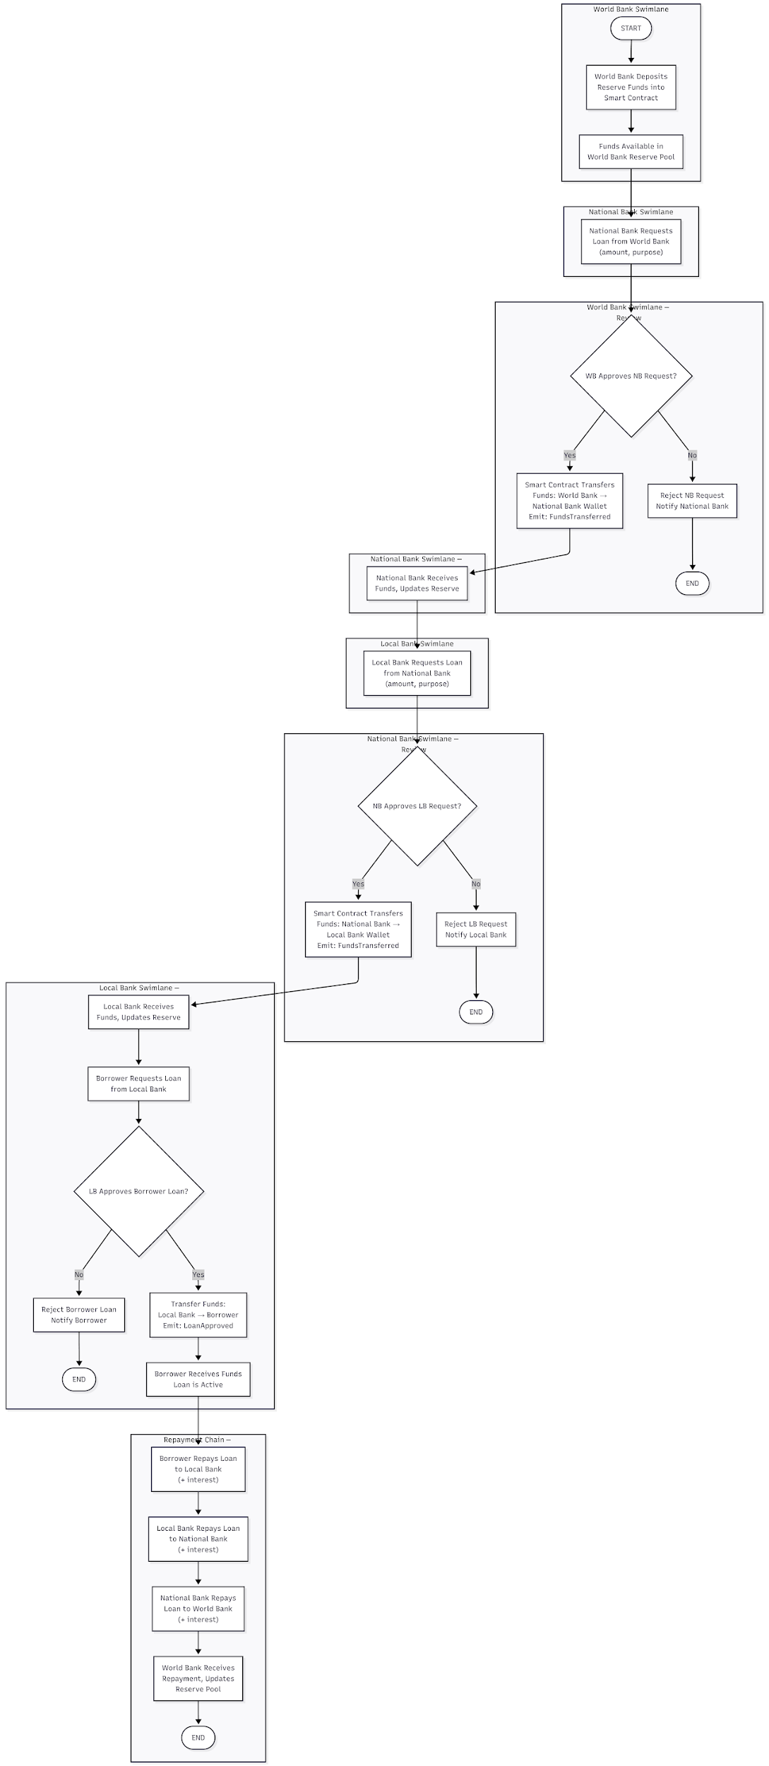
Description: Flow of funds and operations across World Bank, National Bank, and Local Bank.
5.3 Income Verification Flow
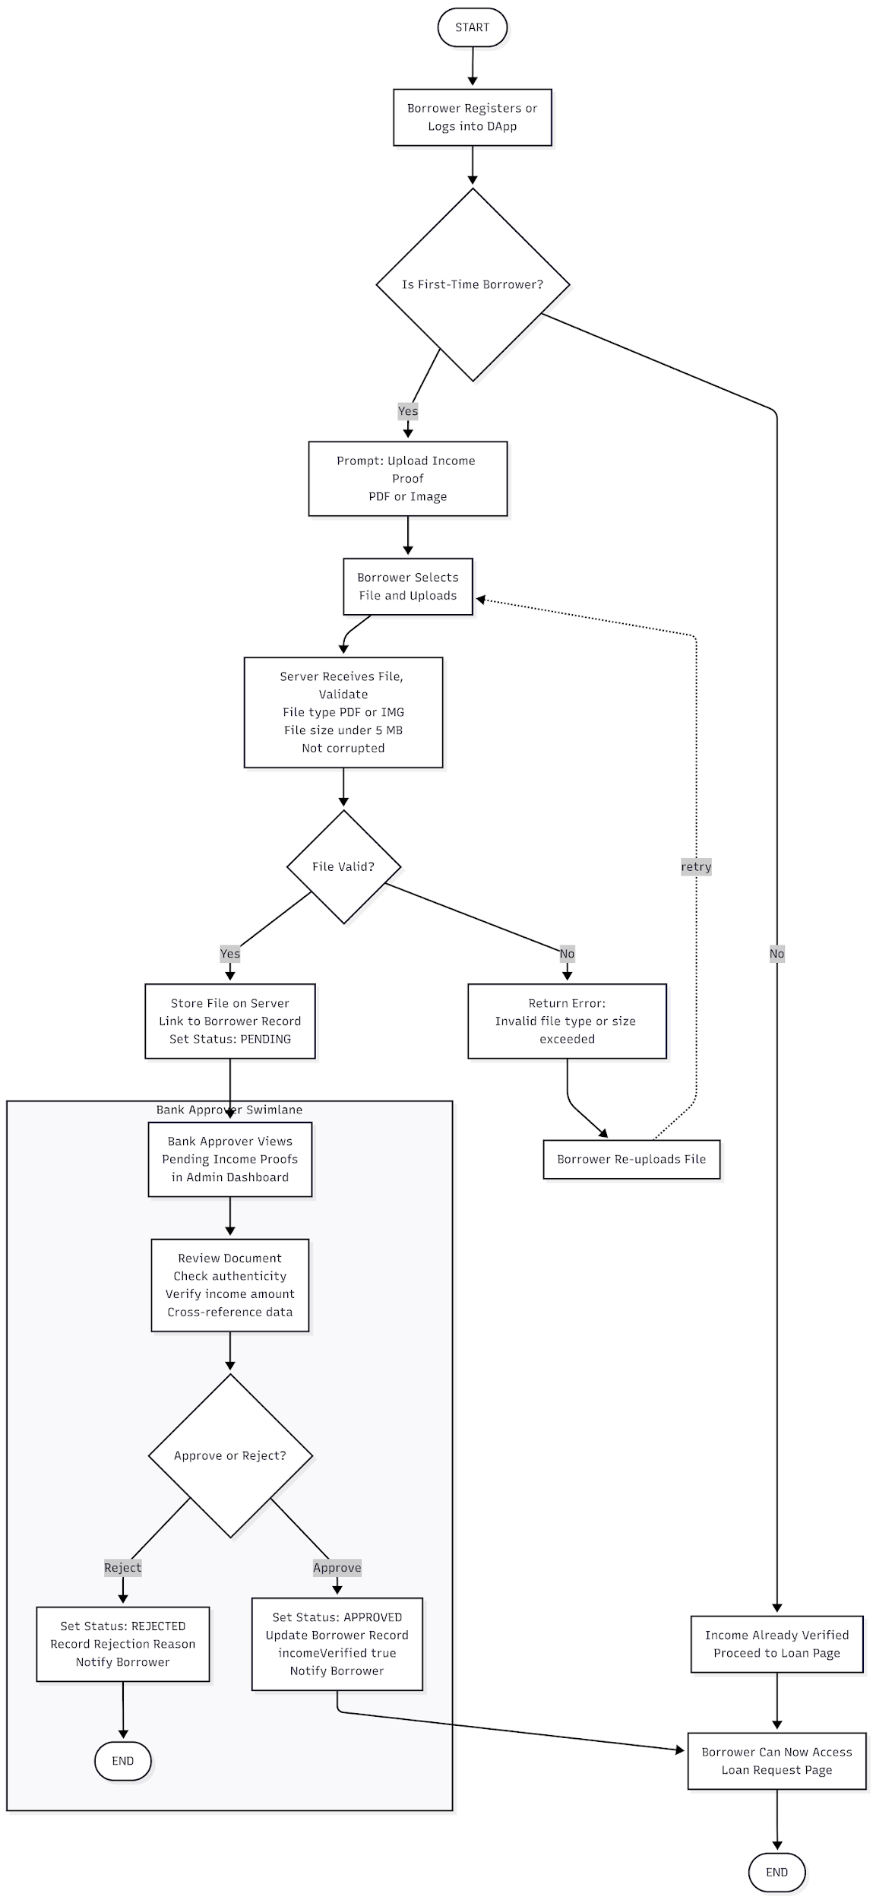
Description: First-time borrower income proof upload and bank review process.
5.4 Chat System Flow
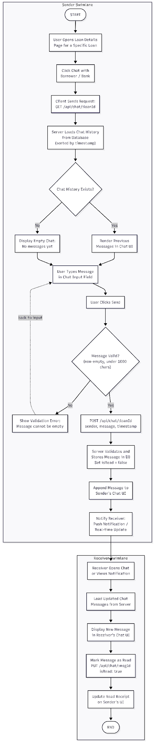
Description: Borrower–bank messaging flow within a loan context.
5.5 AI Chatbot Interaction Flow
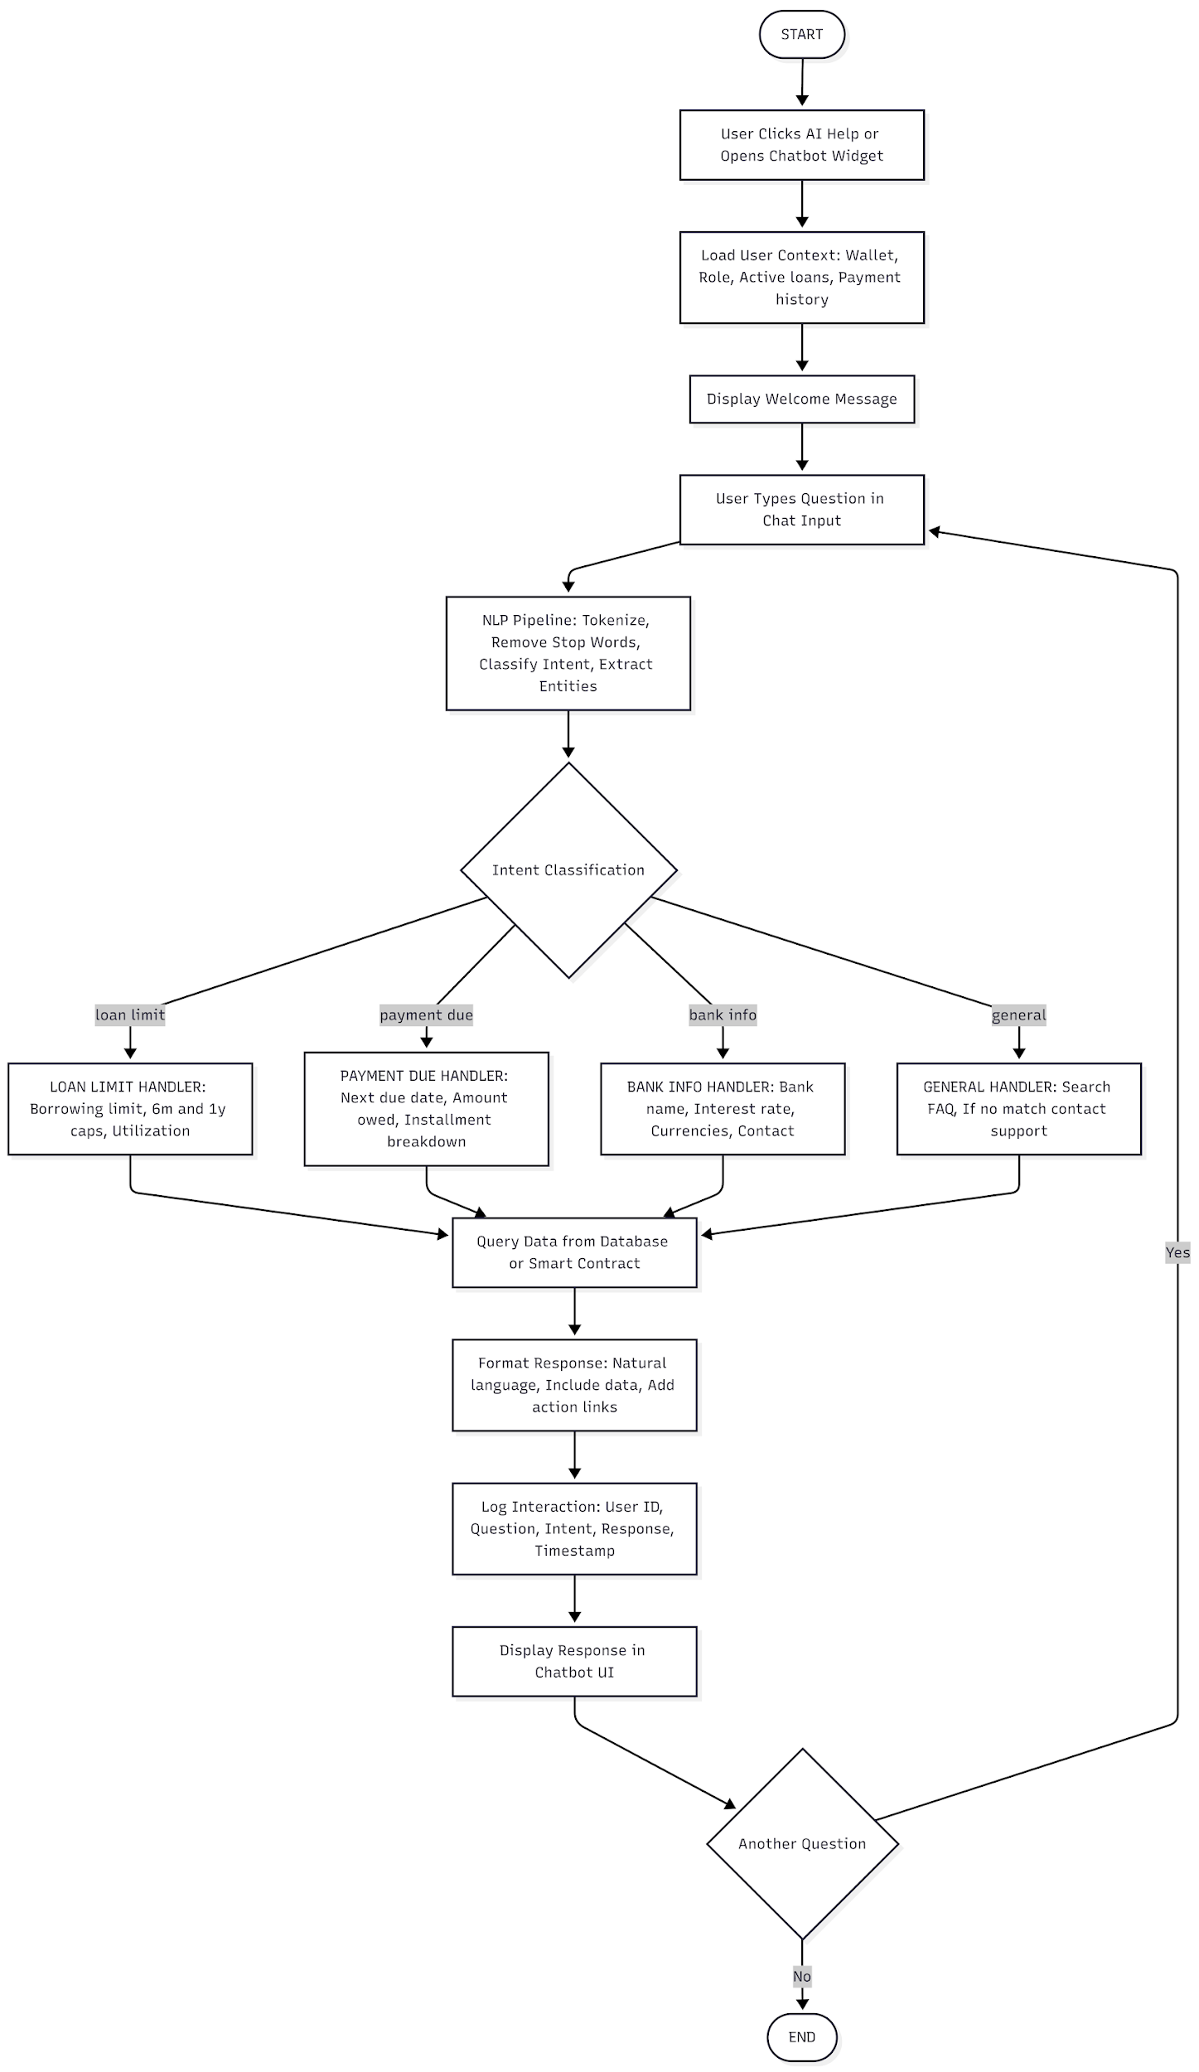
Description: User interaction with the AI chatbot for queries and support.
5.6 Market Data Viewing Flow
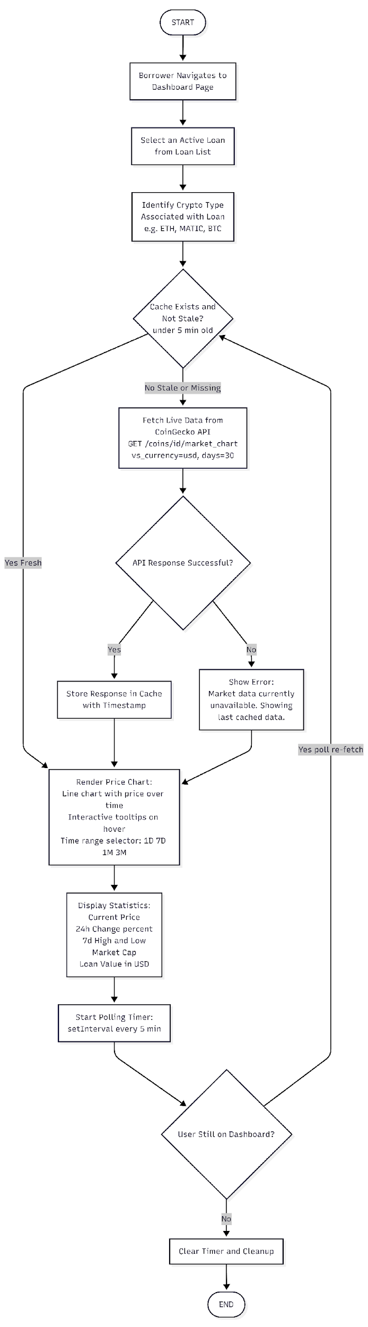
Description: Flow for viewing cryptocurrency market data and prices.
5.7 Profile Management Flow
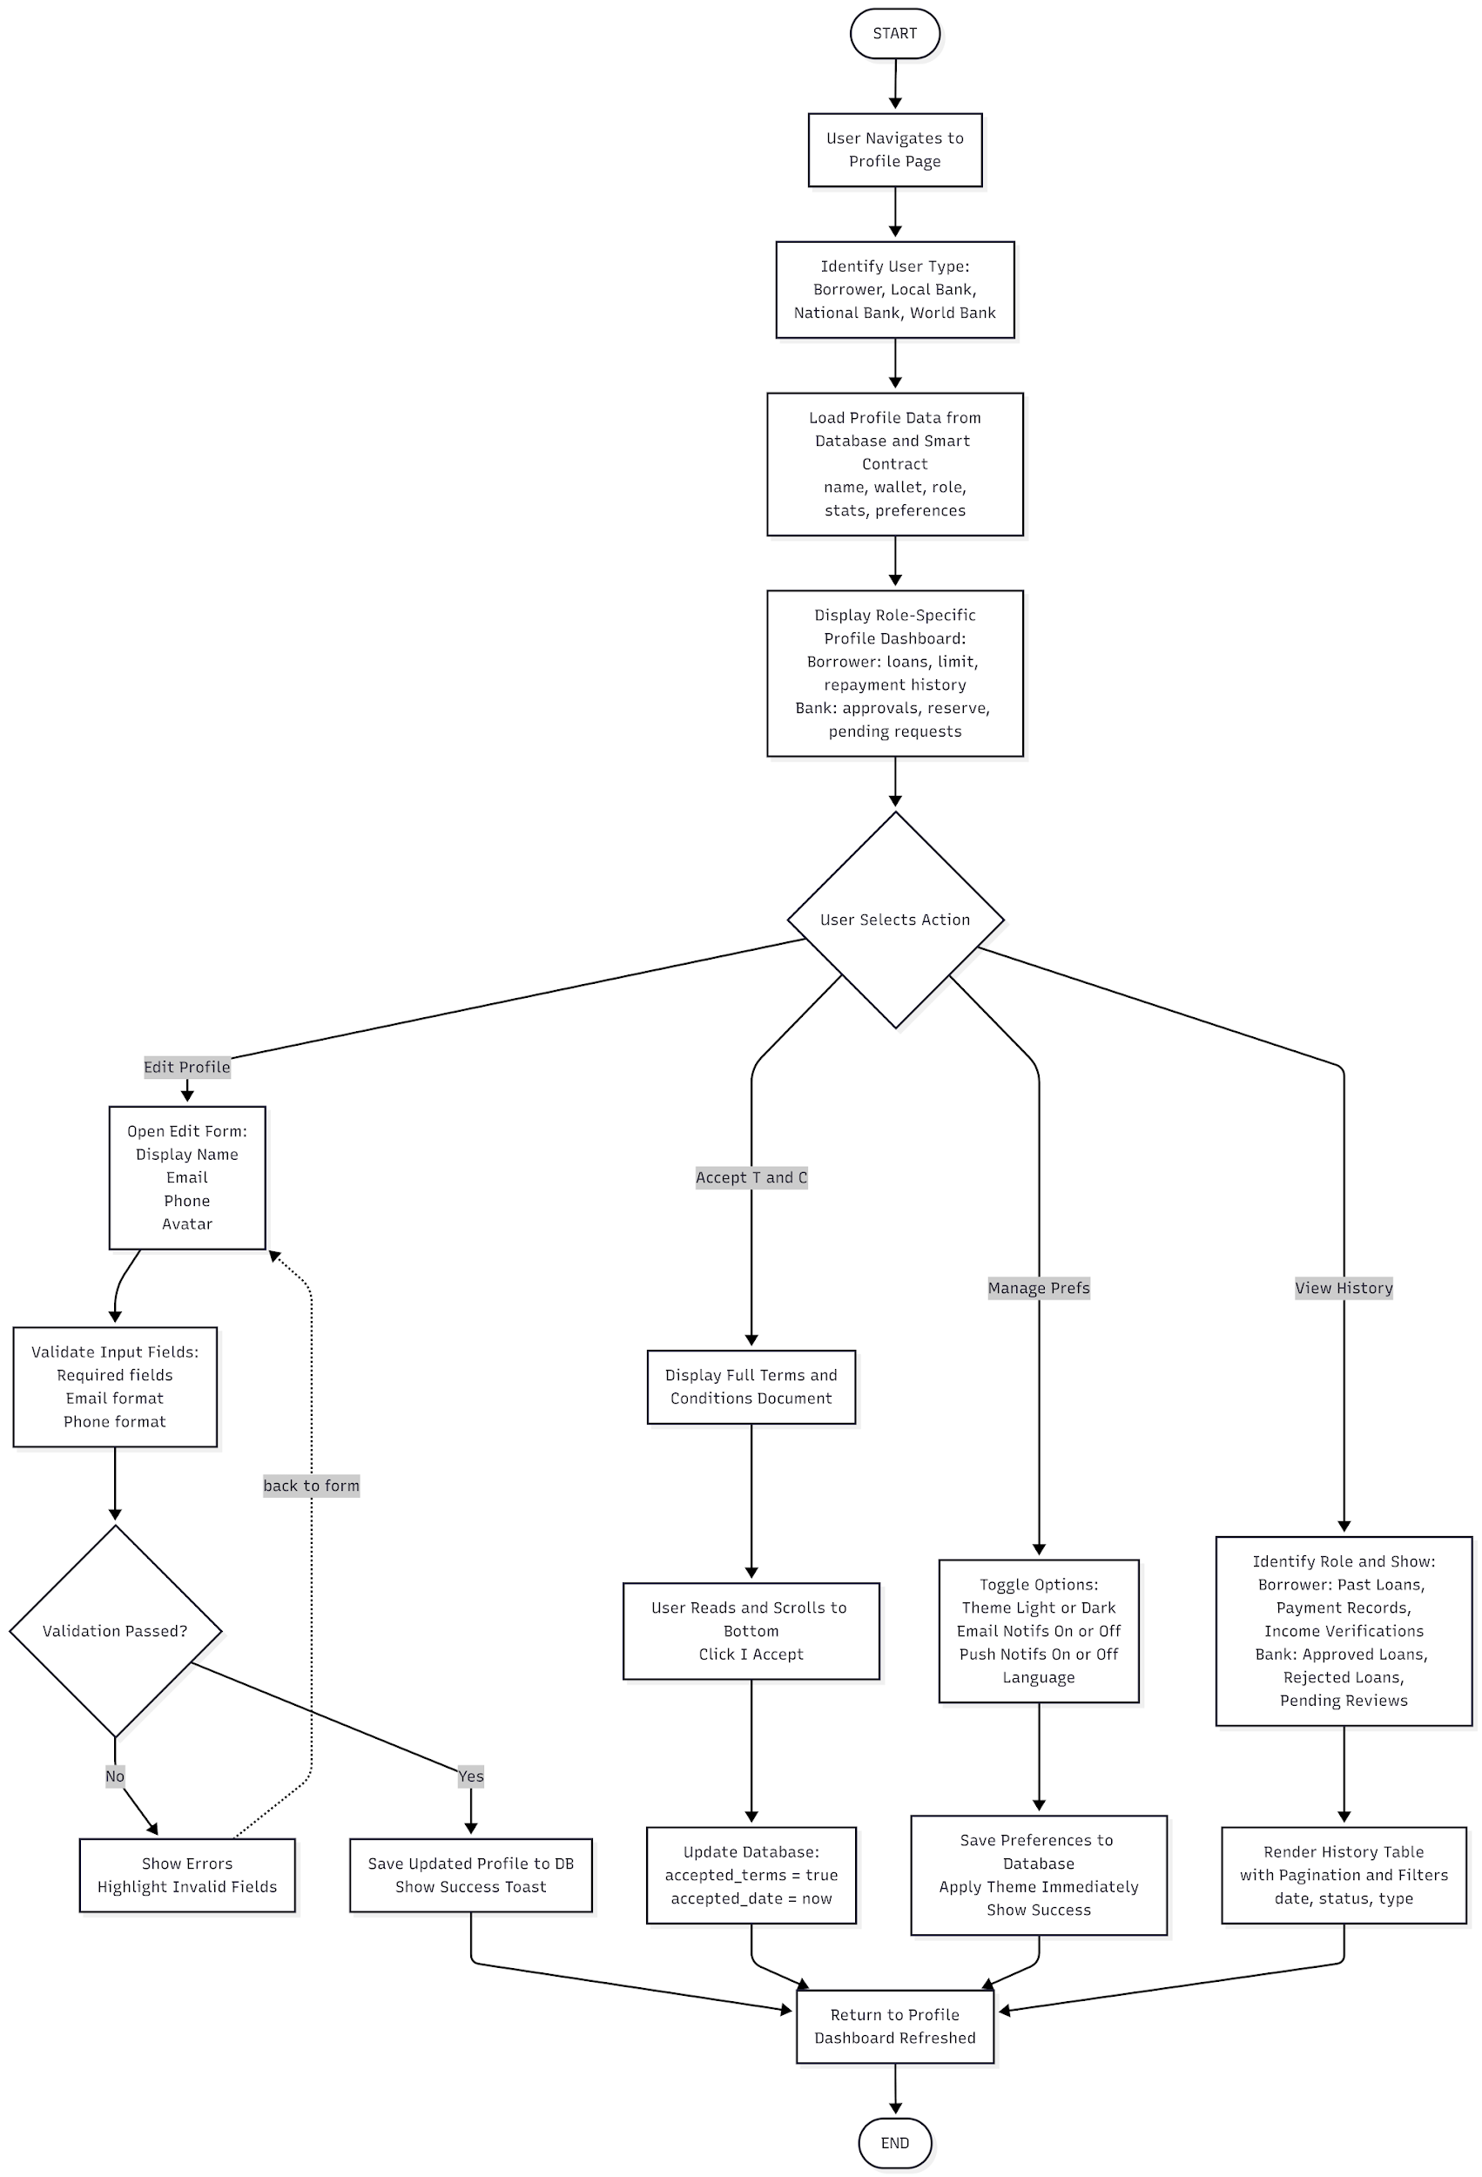
Description: User profile setup, terms acceptance, and preferences.

6. Data Flow Diagrams
6.1 Context Diagram (Level 0)
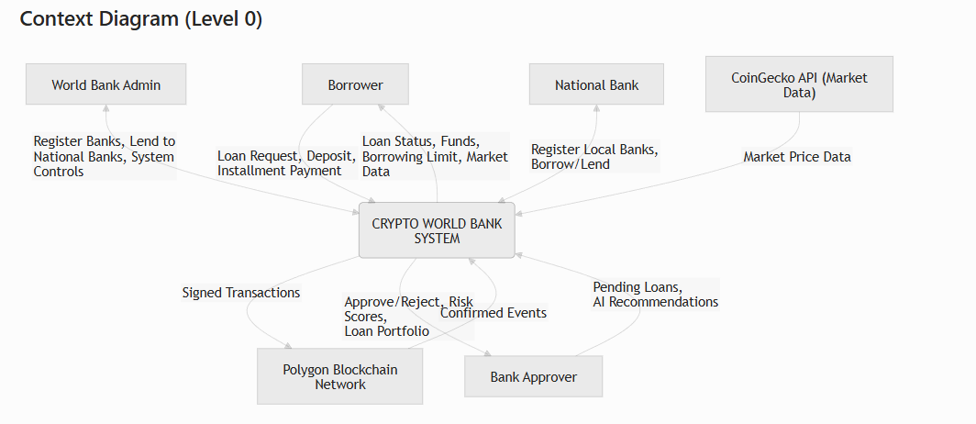
Description: High-level view of data flows between external entities and the system.
6.2 Data Flow Diagram Level 1
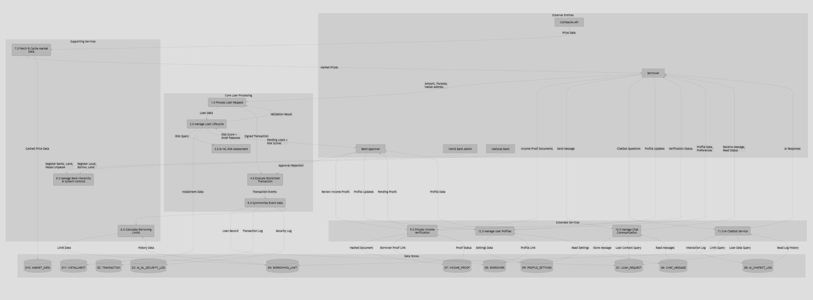

Description: Decomposed view of internal processes and data flows.

7. Sequence Diagrams
7.1 Loan Request, AI Risk Check, and Approval
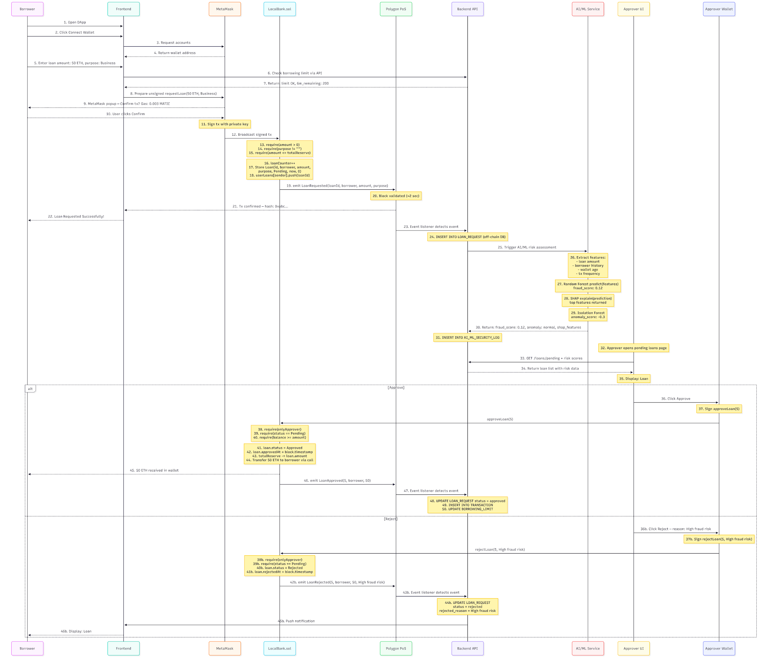
Description: Borrower submits loan request; system performs AI risk check; bank user approves or rejects.
7.2 Reject Path (Alternative)

Description: Alternative flow when bank user rejects a loan request.
7.3 Installment Payment Loop
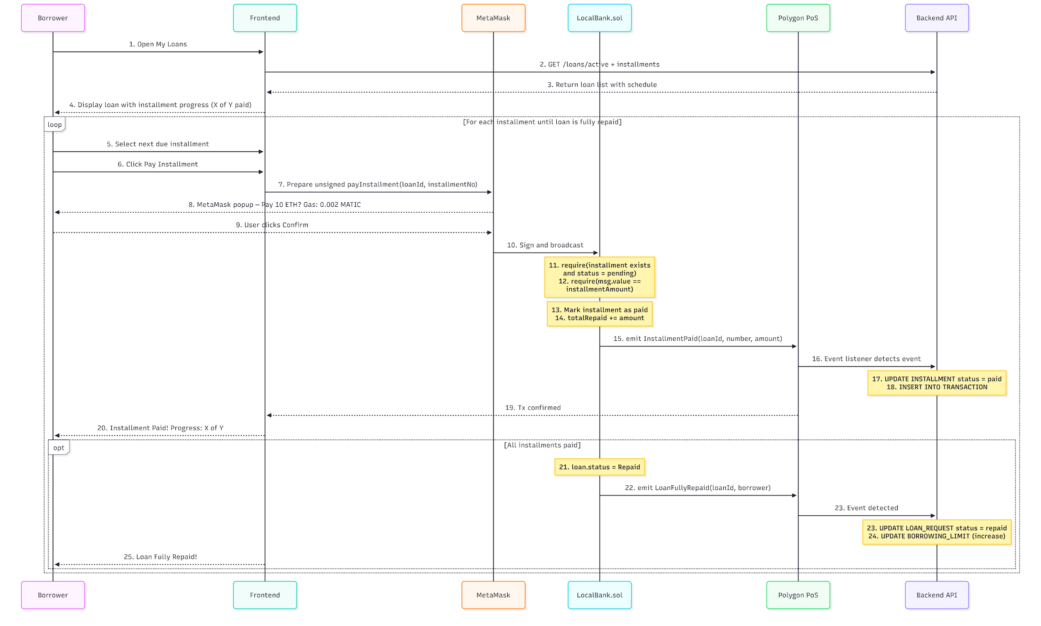
Description: Borrower pays installments; system updates loan status until completion.
7.4 Income Verification
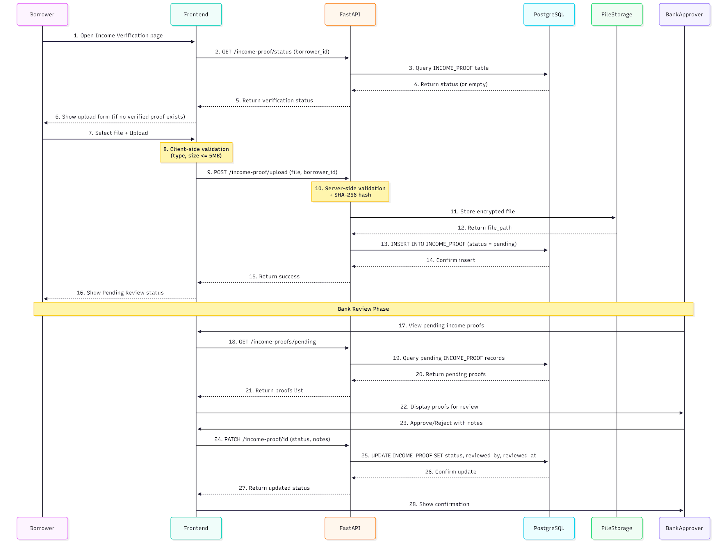
Description: Borrower uploads income proof; bank user reviews and approves/rejects.
7.5 Chat System
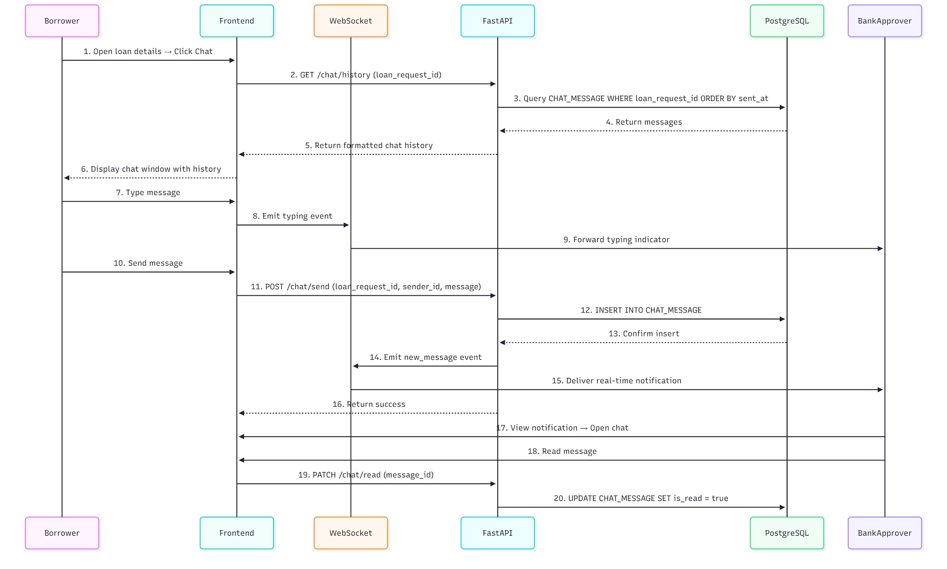
Description: Message exchange between borrower and bank within a loan context.
7.6 AI Chatbot Interaction
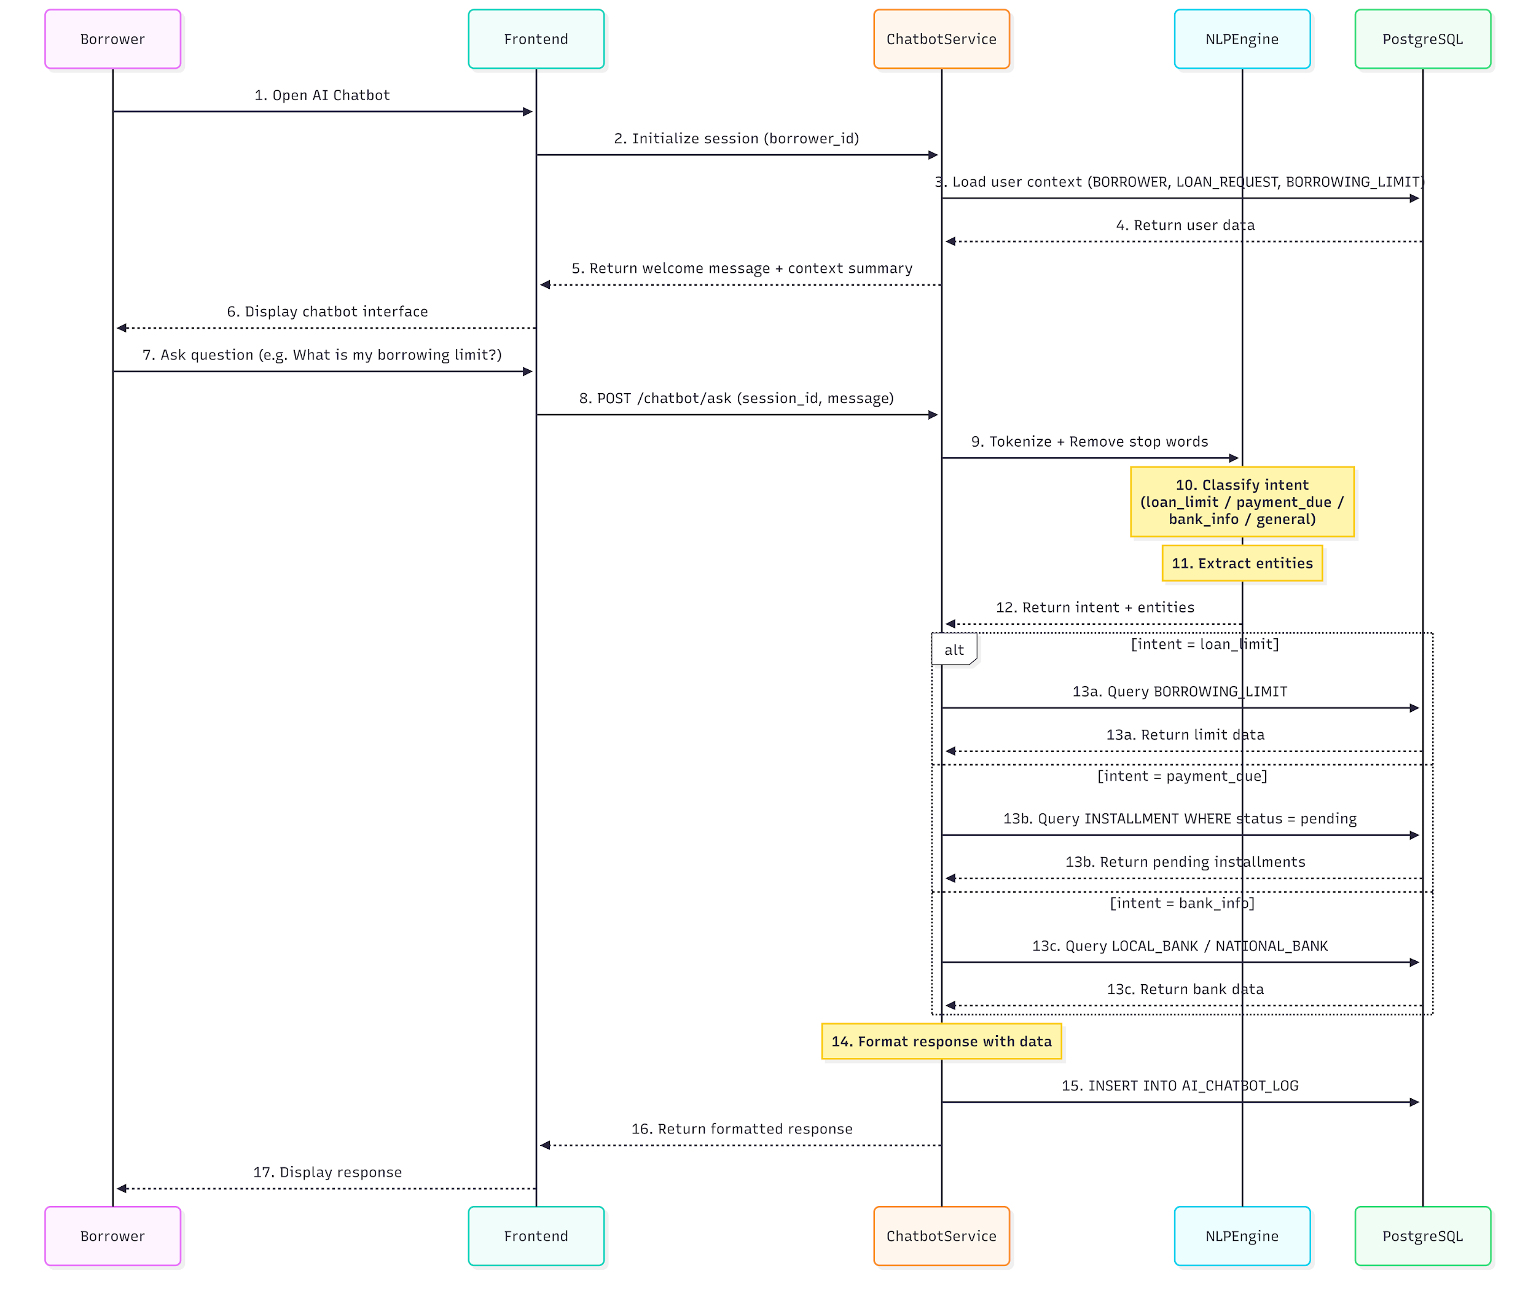
Description: User asks question; AI chatbot processes and responds.
7.7 Hierarchical Banking (WB → NB → LB → Borrower)
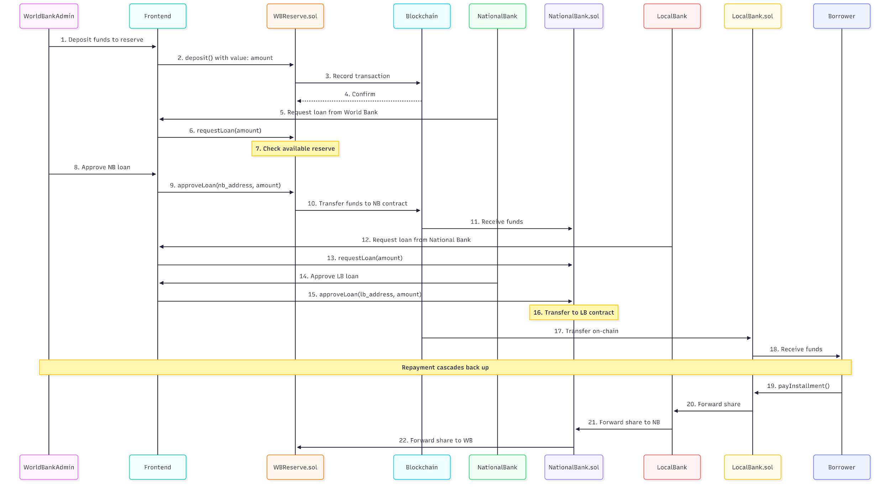
Description: Fund flow and interactions across the banking hierarchy.
7.8 Market Data Retrieval
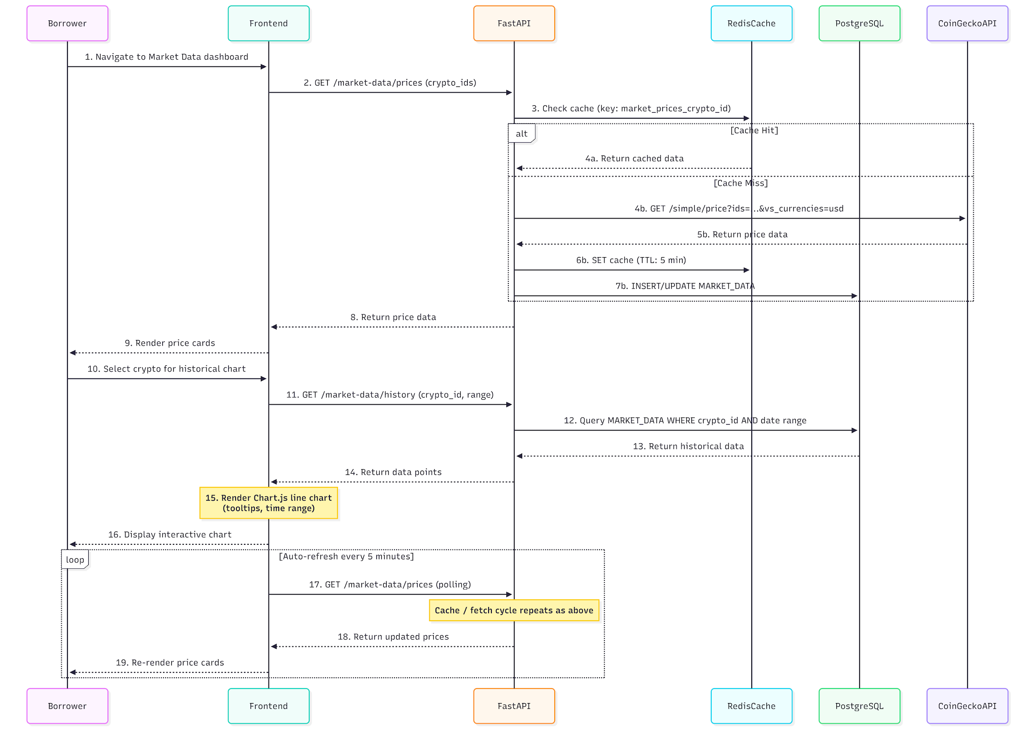
Description: System fetches and displays cryptocurrency market data.
7.9 Borrowing Limit Calculation
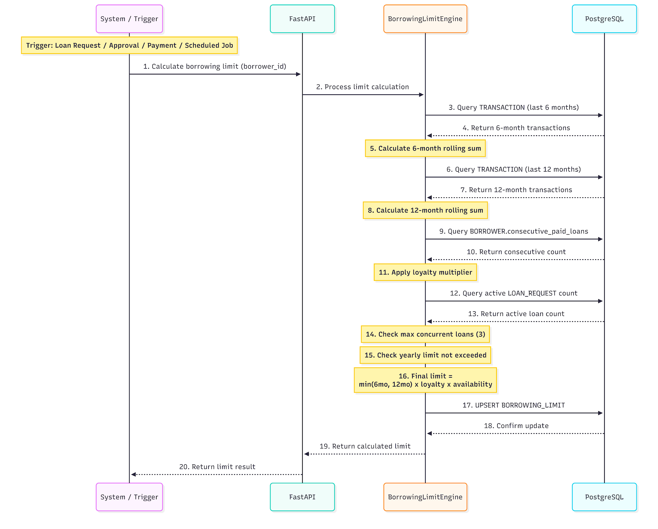
Description: System calculates borrower's 6-month and 1-year borrowing limits.

8. Structure Charts and Program Specifications
8.1 Structure Chart (Logical → Physical Process)
Crypto World Bank System
├── Loan Management Module
│ ├── Request Loan (form validation → contract call → DB update)
│ ├── Approve/Reject Loan (permission check → sign tx → event listener)
│ └── Pay Installment (schedule fetch → contract call → status update)
├── User Management Module
│ ├── Connect Wallet (provider → address → role lookup)
│ ├── Profile (fetch/update settings, terms acceptance)
│ └── Income Verification (upload → hash → store → notify bank)
├── Communication Module
│ ├── Chat (send/receive messages, read status)
│ └── AI Chatbot (NLP → intent → response)
└── Admin Module
├── Risk Dashboard (fetch logs, display scores)
└── Market Data (API fetch → cache → chart)
8.2 Program Specifications (Sample)
Module | Input | Process | Output
Request Loan | amount, purpose, wallet, bank_id | Validate limit, call contract, store tx_hash | loan_id, status
Borrowing Limit | borrower_id | Sum transactions in 6mo/1yr windows, apply rules | six_month_remaining, one_year_remaining

9. Logical to Physical Data Models
Logical (ER) | Physical (Implementation)
Entity BORROWER | Table `BORROWER` (PostgreSQL); wallet_address indexed
Relationship BORROWER → LOAN_REQUEST | FK `borrower_id` in `LOAN_REQUEST`
Attribute blockchain_tx_hash | VARCHAR(66), UNIQUE, for explorer links
Polymorphic CHAT (sender/receiver) | `sender_type` + `sender_id` (borrower vs bank_user)

Data storage formats: PostgreSQL (relational); blockchain (immutable ledger); file storage for INCOME_PROOF (path + hash in DB). Indexes on frequently queried columns (status, date, wallet).

10. User Interface Design
10.1 Navigation Design
• AppBar: Logo, role-based menu (Dashboard, Loans, Deposit, Chat, Profile, Risk Dashboard for bank users).
• Routes: `/`, `/loan`, `/deposit`, `/chat`, `/profile`, `/risk-dashboard`, `/market`.
• Breadcrumbs: Context within loan/chat flows.
10.2 Input Design
• Loan request: Amount (number), purpose (text), bank selection (dropdown).
• Wallet: MetaMask/WalletConnect connect button; address display (truncated).
• Chat: Text input, send button; file upload for income proof (PDF, image).
10.3 Output Design
• Dashboard: Cards for active loans, borrowing limit, pending requests.
• Loan list: Table with status, amount, deadline, pay button.
• Risk dashboard: Table of flagged loans, risk scores, SHAP explanations.

11. Project Timeline and Resource Allocation
Week | Module | Resources
1–3 | Foundation (contracts, UI, DB) | 2 developers, Sprint 1
4–6 | Lending, Chat, Profiles | 2 developers, Sprint 2
7–8 | AI/ML, Testing, Deployment | 2 developers, Sprint 3

Aligns with CSE471 Lab: Module 1–4 (5 features each) over Weeks 4–8. See CSE470_SOFTWARE_ENGINEERING REPORT.md for detailed sprint backlog.

12. Diagram Summary
Type | Count | Purpose
Use Case | 1 | Actor–system interactions
Data Flow | 3 | Data movement (context + level 1)
Activity | 7 | Process flows
Sequence | 9 | Message/event ordering

Document Version: 1.1
Course: CSE471 - System Analysis

